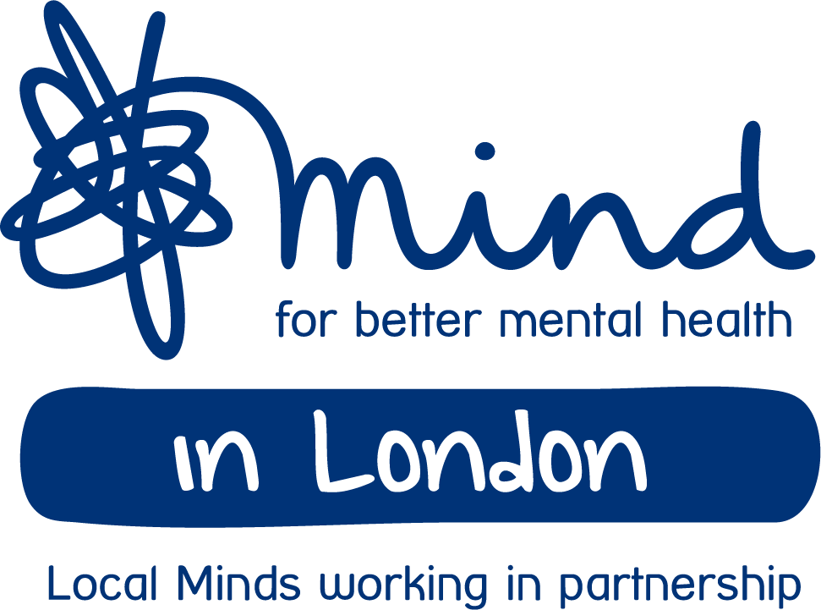

Application form
First name: |  | Surname:
London Borough :
Daytime No: |  | Evening No:
Mobile No: |  | Email:

Please tell us if you have any preferences for how we can contact you:
E.g. Please don’t call between 9am – 5pm Mon – Friday

Please tell us in the boxes below how you meet the specified criteria

Tell us about your lived experience of a mental health problem or being a carer for someone with a mental health problem:
Upto 300 words

Please describe a specific service you have used or have knowledge of:
Upto 400 words

Why are you interested in mental health policy and campaigns:
Upto 400 words

Are you able to use Zoom:
Yes/No – please delete

Are you able to travel once it is safe to do so:
Yes/No – please delete

Would you like to share any additional information :
Upto 300 words

We may record (audio) the meetings in order to create a summary of each meeting and to ensure we capture all feedback for the purposes of influencing our work.  No copy will be kept, we will destroy the audio recording once the content has been summarised.  Please confirm you are happy for this to take place | Yes / No

Please tell us if you have any specific requirements or need support to participate:
E.g. If you require someone to accompany you to the workshop

Please return this form and the monitoring form to Femina Makkar by: 5pm on 12 March 2021
- E-mail attachment to: f.makkar@mind.org.uk

How we process the information you provide
We take your privacy seriously and promise to never sell your data. We will use the information you have provided to administer your application. If your application is unsuccessful, we will delete your data. Once you have been recruited, we will contact you about the role.
You can find out more about your rights, how we use your personal information and how we keep your details safe and secure by reading our Privacy Policy. For more information or to withdraw your consent to us processing your data, contact our Supporter Services team at supporterservices@mind.org.uk or on 020 8215 2243. Please note that when you update your communication preferences it can take up to 28 days to take effect.

