Document Control:
Ref:
Issue Date: 2022
Lived Experience Policy
Mind | √
Mind Retail | √

Lived Experience Policy
Ensuring that people with mental health problems drive all that we do

Summary

- This policy sets out Mind’s principles of lived experience leadership which informs the work of all Mind staff.
- The policy explains why involving people with lived experience is important and the importance of ensuring opportunities are accessible to a diverse range of people.
- Payment information outlining who we pay, for what and how is included in this policy.
- The policy should be read in conjunction with the Influence & Participation Toolkit. The Toolkit provides practical guidance and templates to support Mind staff to embed lived experience leadership in their day-to-day work.

Policy agreed on:
By:
Review date:

Contents

Summary 1
Contents 2
1. Introduction 3
2. Ethos 3
3. Roles and Responsibilities 5
4. Risk and Compliance 5
5. Payment 5
6. Monitoring 7
7. How we do this 7
8. Support 9
Appendix 11

Introduction

  - At Mind we provide advice and support to empower anyone experiencing a mental health problem. We campaign to improve services, raise awareness, and promote understanding.
To do that effectively, Mind works hard to understand the needs and experiences of people with mental health problems and we actively seek opportunities for people with lived experience of mental health problems to influence and share decision making in our work. It is not enough to rely on our own experience and the experience of those around us.
  - Lived experience is the knowledge and understanding you get when you have lived through something. For Mind this predominantly focuses on people who have mental health problems as well as the insights of particular groups who are at risk of mental health problems / who do not identify as having mental health problems
  - Leadership in this context means people with lived experience working with Mind, sharing decision making and steering Minds work. This ensures people are able to use their skills & experience as well as build confidence.
  - Mind defines ‘Lived experience Leadership’ as:
‘The development and promotion of opportunities in which a diverse range of people, with lived experience of a mental health problems, influence Minds work at all levels. This recognises that people want to take part in a variety of different ways and there is not a ‘one size fits all’ approach.’
  - You are expected to plan Lived Experience opportunities at all stages of your work to ensure a variety of approaches and build in shared decision making wherever possible. When planning activities, you can refer to the levels of participation graphic to consider how much decision-making power you are sharing.
  - Every opportunity at Mind should support individuals to develop their leadership skills in some way. The aim is that everyone has an opportunity to grow through their lived experience leadership experience at Mind. Taking part should support wellbeing, career development and ability to effectively contribute to other mental health work nationally and locally.

Ethos

  - Lived Experience Leadership is everyone’s responsibility. If what you do affects people with mental health problems, you can’t do it effectively unless you widely engage with people with mental health problems.
It is essential to:
- Build Lived Experience leadership into all our strategy, programme, and communication plans.
- Ensure that we provide for it in all budgets including reasonable adjustments.
- Include a diverse range of people, of all ages from both nations.

  - Our approach to influence and participation is guided by four main principles:
- Equality
No one group or person is more important than any other group or person.
- Diversity
We work proactively to include as diverse a range of people as possible in our lived experience leadership work.
- Accessibility
Accessibility is about ensuring that everyone has the same opportunity to take part fully in activities in the way that suits them best. Important accessibility issues include location, language, physical access, information sharing, and times and timing.
- Reciprocity
Reciprocity can involve paying people, but also involves providing opportunities for personal and professional development and letting people know the impact their involvement had.
  - Lived Experience Leadership benefits Mind and people with lived experience. Read more about this in the Influence & Participation Toolkit.
  - When specifically seeking input from people from marginalised communities, it is essential to connect with groups, organisations and community leaders working with the community you need to reach. It is important to build reciprocal relationships in advance.
The Lived Experience Unit can support you to plan this type of promotion. Contact: LivedExp@mind.org.uk
  - In addition to working in accordance with Mind’s values, our approach to Lived Experience Leadership with adults, children and young people is informed by good practice guidelines produced by other organisations, including:
- National Survivor/User Network (NSUN) Involvement Standards (4Pi)
- Social Care Institute for Excellence (SCIE) Co-production Principles
- United Nations Convention on the Rights of the Child (primarily Article 12)
- Children and Young People’s National Participation Standards (Wales)

3. Roles and Responsibilities

  - It is everyone’s responsibility to ensure that lived experience leadership is embedded into Minds work.
  - The Youth Voice Network team support teams to recruit young people and create opportunities for young people to influence change. Youth Voice Network (11 – 24yrs) - youthvoice@mind.org.uk
  - All teams are allocated a Lived Experience Leadership coach to support them in this work. Lived Experience Leadership (18+yrs) – LivedExp@mind.org.uk

Risk and Compliance

  - GDPR must always be adhered to.
  - If staff are concerned about a young person being at risk to themselves or to others, they must share this with line manager and complete an incident report form. In some safeguarding cases, to gain consent from the person who holds parental responsibility for the child may be deemed as putting the child at significant risk. In this event and as we await Minds CYP Safeguarding policy (under review) please speak with Vanessa Joseph (YVN Manager) & Nicola Youens (Safeguarding Manager).
  - Physical and emotional risks must be considered before people take part.
  - Where we are involving people in our work in public facing roles it is important to ask if anything is / has taken place in their life that could be harmful to Mind’s reputation. Should they disclose anything please complete an individual risk with the support of Mind’s Safeguarding Manager to decide on next steps, in most cases the participation will be able to proceed with mitigating actions in place. There may be occasions where Mind decides it is not appropriate to continue with the participation activity.
  - Consider all risks when using online platforms. Zoom and MS Teams are preferred providers for video calls & conferencing. Please refer to Mind’s Compliance and Quality team to ensure that the platform you are using is compliant.
  - Lived experience consultants should be recruited to roles where decision making is shared or work is being carried out on your behalf i.e. Peer Researchers, Youth Voice Network members, Lived Experience Coaches, Lived Experience Designers, project leads, Equality Improvement consultants.
Always contact LivedExp@mind.org.uk for support with recruitment processes, payment, checks and contracts.

Payment
  - Payment guidance is different for Lived Experience Leadership and the Youth Voice Network. Appendix 4 outlines the payments tables for each group.
  - We pay or incentivise people with experience of mental health problems who share their time and expertise to influence our plans or who contribute to the work we deliver.
  - It is essential that all teams ensure that payments are appropriately budgeted for within their programme budgets. You will need to take into account potential additional costs including but not limited to childcare, carer’s costs, and translator / interpreter costs. You should ensure there is flexibility within you budget.
  - All payments must be made in line with this policy, if you are unsure what the appropriate payment is for your activity please contact LivedExp@mind.org.uk
3.5 Hourly payments must not be made under any circumstances; payment must be clearly stated in all promotion and relevant correspondence. It is recommended that when you promote influencing and participation opportunities that you state the length of the task and the related fee e.g. £25 for 2 hours of reviewing an information booklet.
  - Young people recruited from the Youth Voice Network, regardless of age are not paid. Vouchers to thank them for their involvement and other incentives such as training are offered to young people. To understand more about the rational for this see appendix ‘x’. If you are engaging with children please inform the Youth Voice Network team to discuss how best to support them and thank them for their insights.
  - Mind does not accept responsibility for the impact that accepting a payment may have on someone’s benefits and / or HMRC tax responsibilities. Due to the individuality and complexity of this, Mind cannot provide advice to individuals. It is staff’s responsibility to ensure participants understand they are responsible for declaring their income to HMRC and the Department of Works & Pensions, and that they are responsible for paying any tax and National Insurance due.
You may find the following paragraphs helpful if you are asked questions about tax and benefits by people engaging in your work:
“Payments are made in recognition of a contribution of time and expertise, they count as income and are therefore covered by the tax and benefit rules around declaration of earnings. It is important to understand that they may impact the amount of tax you need to pay and the amount of benefits that you are entitled to. We cannot give advice on individual tax and benefit positions and therefore it is your responsibility to ensure that you are aware of the tax and benefit implications.
If you need advice speak to your local Benefits Advisor, Citizens Advice Bureau or see the information on the www.gov.co.uk”
  - Travel should be pre-booked by Mind staff wherever possible to ensure no-one is out of pocket to take part. Accommodation should be offered if the participant has to travel over 3.5 hours to take part. People should not be required to leave home before 7am or return after 9pm, without being offered accommodation.
All accommodation should be booked by Mind staff in line with Mind’s Expenditure, purchase order and budget management policy.
Maximum £75 per night outside of London
Maximum £100 per night in London
Subsistence should also be offered, at the same rate as Mind staff if a person needs to travel over 3.5 hrs. Expenses are listed on the participation claim form and submitted with receipts.

Monitoring

  - To help us understand and evidence who is influencing and participating in our work staff are required to enter monitoring and demographic data into the Influence and Participation database. In doing this we are able to build a picture of who is, and subsequently isn’t influencing our work, so we can improve our approaches in the future. The database needs completing for each activity by the end of each quarter. You can enter at any time, but your entry needs to take place by the end of each quarter. Resources to guide you are located on the intranet. Please ensure you ask all participants to complete a demographic monitoring form and feedback form at the time of the activity as you will need this information to complete your entry
  - As the capacity of our CRM system is developed this will become an additional tool for data monitoring. Children and Young People’s data is recorded on the CRM, and is managed by the Youth Voice Network Team who ensure the data is up to date and safe. Enquires for Children and Young People’s demographics should be directed to the Youth Voice Network Team.
  - All heads and managers are required to write an annual Influence and Participation plan; support will be provided by the Influence and Participation Coaches and Manager between Jan – March. Targets need to be set by each team; activity will be monitored against the targets each quarter and reported to MET and Trustees.

How we do this

  - Opportunities to influence and participate in our work should be promoted as widely as possible. We must do our best to ensure as diverse a range of people have the opportunity to take part, as well as people new to Mind, in order to achieve this our promotion should be distributed as widely as possible. Opportunities can be sent to the Lived Experience Leadership team to promote in their newsletter.
Mind Membership is the primary place to promote lived experience leadership opportunities and has regular postal and e-communications. Other places to promote opportunities include:
- People who fundraise for Mind
- Digital supporters E.g. Social media & Elefriends
- Peer Support mailing list
- People you have previously worked with who have given you permission to contact them again.
External organisations such as National Survivor User Network (NSUN) and National Voices are useful places to promote opportunities.
Your engagement coach and Equality Improvement partner can help you think through which promotion channels to use, as well as how to promote to less heard groups.
When specifically seeking input from people from marginalised communities, it is sometimes useful to send opportunities to specific contacts, groups and organisations that you or your colleagues may have already developed or know about. The Equalities Improvement team can support you to plan this type of promotion
  - Ensure you are not working with the same people every time you run an activity, it is important to let others have their say. They may have different experiences to the people you regularly work with that would progress your work.
  - We do this by:
- Building Influence and Participation into all of our programme and communication plans.
- Ensuring that we provide for it in all of our departmental budgets.
- Ensuring that we continually identify influence and participation opportunities to improve our ongoing work.
- Using a range of tools and techniques to meet the needs of people from different backgrounds and life circumstances.
- Adapting the techniques we use to work with new audiences e.g. children and young people, people with learning difficulties and older people.
- Identifying groups of people who might face barriers to accessing our work and engaging with us, and proactively taking steps to overcome those barriers so that we learn from their experiences and make our work as inclusive as possible. This often involves going to where people already meet and feel comfortable, rather than asking them to come to us.
- Ensuring that we provide adequate support for those who take part, as sharing a mental health related experience can be painful.
- It is your responsibility to ensure that you get the support you need, this is especially important when exploring sensitive issues with people.
- Completing a risk assessment so we understand potential risks to participants and staff and manage these as effectively as possible.

Support

  - It is important to offer those taking part appropriate and relevant support, this can take many forms and will differ depending on the method you are using, topic being discussed and age of those taking part. The Influence and Participation toolkitcovers this topic in more depth and includes tools and templates to help you offer the most appropriate support.
Consider:
- What support is feasible for you to offer e.g. A quiet break out space, having an MHFA on-site, offering to complete a WAP plan if the opportunity is long term.
- If training is appropriate. Training gives people more confidence in their abilities and can help build their understanding of topics concepts.
- What will you do if someone becomes distressed whilst taking part? Your coach can help you plan for this too
  - The support you offer a young person taking part will need to have a higher level of formality and planning. Always speak to the Mind Influence and Participation Manager before undertaking activities with under 18’s; they will be able to support your planning and ensure you are thinking through all risk factors.
Always:
- Ask for the relevant written consent from parents / guardian / responsible adult of anyone under the age of 18 taking part. Please see the Children and Young People Consent Procedure.
- Ensure children and young people (16 and under) are accompanied to your event by a parent or guardian (always reimburse the travel costs for all attending); parents don’t need to take part or be present during your event however they do need to be present at the beginning and end.
- Ensure you are aware of parent / guardian contact details should you need to reach them during an event. Make sure the child or young person taking part is aware you may contact them should they become distress or unwell and are no longer able to take part.
- You have read the relevant safeguarding policy
- Consider who the best people to facilitate are and be present at your event. Would a facilitator experienced at working with young people be better placed to run the session? Do you need support from youth workers during the session?
- Ensure there are a minimum of 2 members of staff (Mind staff / external facilitator) who have been DBS checked present at all events. This ensures you have enough people to support anyone in need whilst also continue the event.
- Think of methods and language that will be appropriate and length of sessions.

Appendix

Appendix 1 – Lived Experience Leadership Participation at Mind
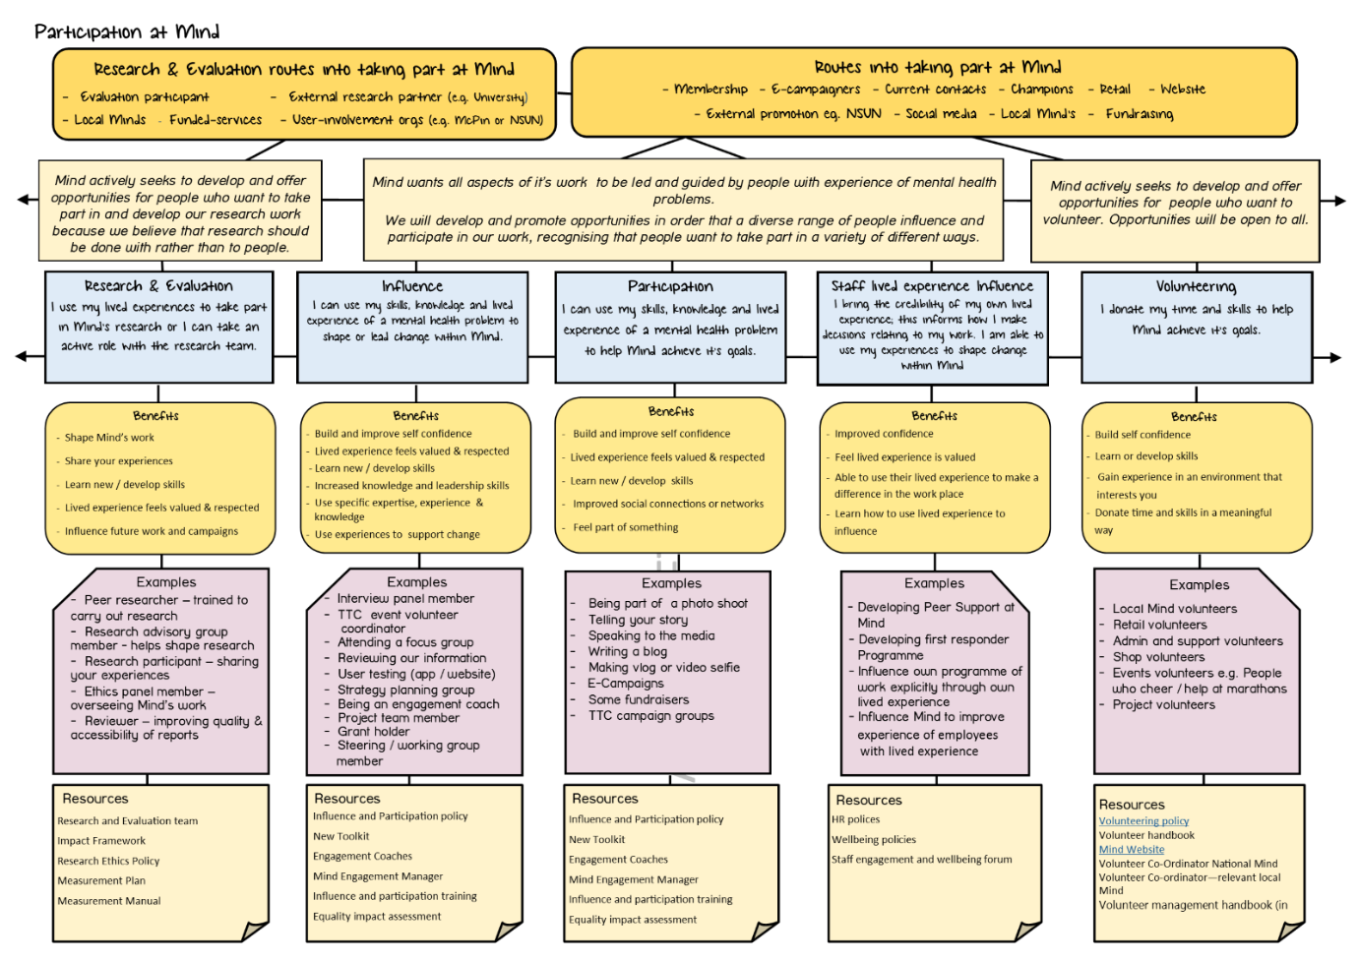

Appendix 2 – Lived Experience Leadership payment guide

Influence | Examples:  Discussion / focus groups, information reviews | Payment:  Less than 1.5hrs – expenses only  1.5 – 3 hrs - £25  3.5 – 5 hrs - £50  5.5 – 7 hrs - £100 | Associated costs  No payment is due if the initiative or activity took less than 1.5hrs  Travel is remunerated; staff to book in advance where possible  Accommodation if length of journey requires this  Subsistence costs in line with Mind’s allowable expenses e.g. Breakfast, lunch, dinner
Participation | Examples:  Speaking to the media, taking part in our campaigning work, attending an event, photoshoot | Payment:  No payment | Associated costs:  Travel is remunerated; staff to book in advance where possible  Accommodation if length of journey requires this  Subsistence costs in line with Mind’s allowable expenses e.g. Breakfast, lunch, dinner
Volunteers | Examples:  Administrative role, data entry, community events volunteers, retail role in our shops, carrying out tasks that don’t relate to lived experience | Payment:  No Payment  Please see the Volunteer policy for full details on required remuneration of expenses
Lived Experince consultants | Examples:  Advisory group  Steering / working group, Influence & Participation Coach, Lived experience / Peer researcher  Defined pieces of work  E.g. short listing for Mind Media awards, developing a resource or writing a report | Payment:  £200  £230 dependent on skills and level of experience needed. There may be occasions where a higher rate of pay is required, this should not exceed £400. Please consult with the Lived Experience Leadership Manager for support in deciding on the correct fee.  A flat rate can be defined for specific pieces of work, this should be discussed with the Influence & Participation Manager during planning.
Training | Example:  Independently leading development of and delivering training  Delivering training (lead or co-trainer)  Contributing your story to training session | Payment:  £400 per day  £200 per day  (both) Travel, accommodation and subsistence where relevant  Always check with the training department & Engagement manager before commencing, this is a guide only  Travel expenses and subsistence where relevant
Research | Example:  Participating in research  Planning and designing research / peer researcher | No payment – An incentive can be offered  E.g. £20 gift voucher for taking part  Please see Research policy for more information  Travel is remunerated; staff to book in advance where possible  See consultant fees above

Appendix 3 – Lived Experience Leadership levels of participation

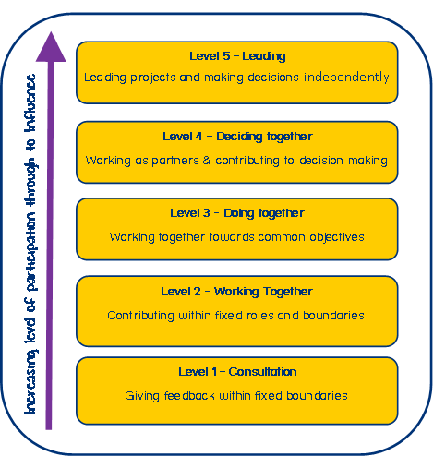

Activity  Appendix 4 – Youth Voice Network Incentives  These incentive costs are a guide to help you with planning and could change depending on your opportunity. Please speak with the Youth Voice Network team who will confirm what your budget needs to be to thank young people. | Description of opportunity | Voucher Amount  Costs are per person, per hour (unless stated otherwise)  Costs do not incl travel reimbursement if being hosted in person
Focus groups | Focus groups allow you to gather opinions on a particular topic in a small group setting | £20
Information reviews | Information reviews can take place via meetings or email. They are used to ensure written, media, brand or other information is young person friendly and understandable.  Where possible co-design is a better method of participation. | £20
Regular steering group | Regular steering groups can be set up when a project requires long-term oversight by young people. | £20
Co-designer | Co-designers work with a team or individual to create content or services as a youth expert. | £40
Panel member | Panel members sit on lived experience panels with others to share their experiences or opinions to influence change, normally this takes place publicly. For example taking part in lunch & learns or The All Staff Briefing | £50
Co-facilitation/facilitation | Young people lead or co-deliver sessions such as focus groups or workshops. | £50
Taking part in research |  | £10-20
Social Media Video | Creating content for Mind’s social media posts. | £10 per post
Filming days | Young people take part in filming/photoshoots for Minds work (excludes media volunteers) | £50 Half day  £100 Full day
Interview panels | Young people are part of an interview panel to recruit Mind staff, freelancers or external companies | £25 Half Day  £50 Full day

