The Umbraco 7 site is built to facilitate Welsh Language across the site we will be developing the functionality as the translated content increases across the site to help with the management of it.

It is important to set the content up correctly so that future developments will track the content in readiness future improvements to the translation functionality, some of the future plans:
- version tracking
- warnings to update the Welsh content if the English is updated
- Viewing all translated content
- Restructure the IA (Information Architecture) of the Welsh section while still linking to the English

There are a few simple rules:
- Currently English pages cannot exist in the Welsh Tree
- No pages should be created in the Welsh tree only copied into it
- English pages must be created first otherwise the relationship between page versions will not be created
- The Welsh content tree can not mirror the English content tree

Creating content

- Create the English version of the page

Adding Translator block
- Add the content block ‘Translator Notifier’ this should be after the page heading text so the user can assess that they are on the correct page
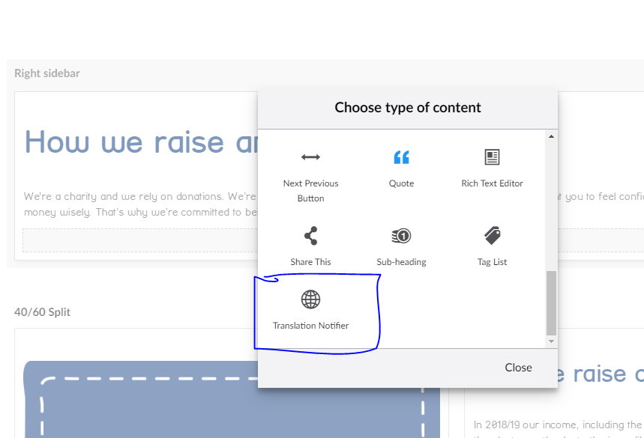

Live page view

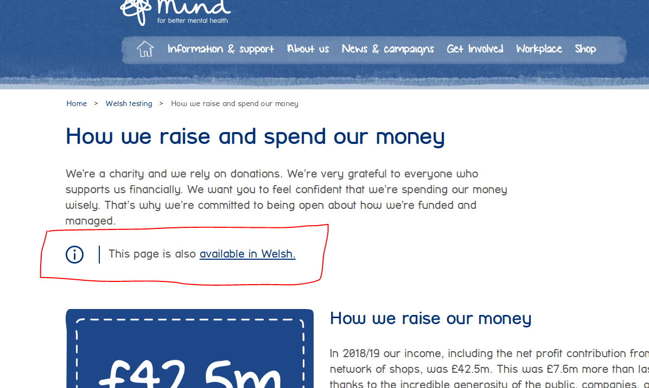

- Save

Coping the page
- Copy the page by right clicking on the three dots to the left of the title and select copy

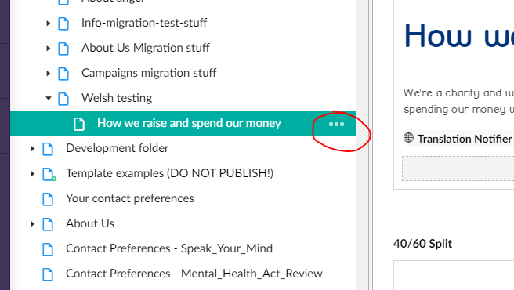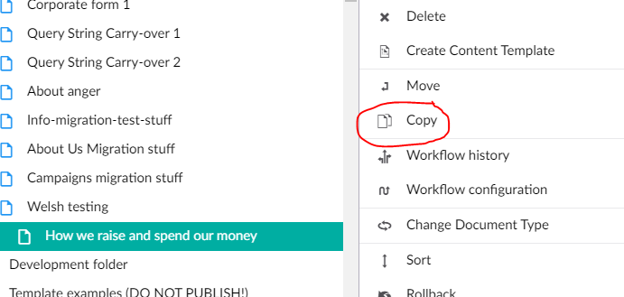

(Continued on next page)
  - Ensure that ‘Relate to original’ is SELECTED this will make the translate function work
  - To copy a single page DESELECT the ‘Include descendants’ option OR if require all the pages in the section SELECT ‘Include descendants’
  - Select the location in the ‘Mind Cymru’ content tree to copy the content to

(see image)
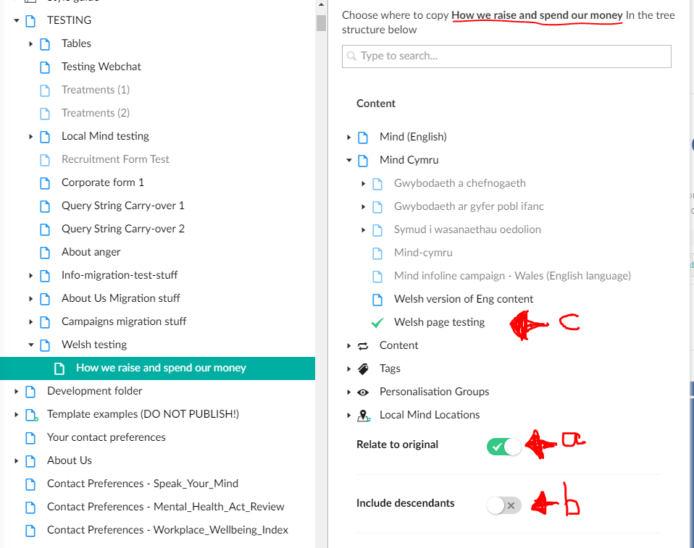
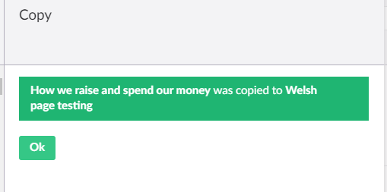

- Now you should see the page/s have been copied over to the Welsh tree and unpublished

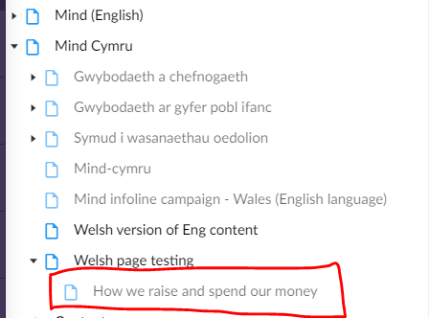

Editing Welsh content

- Select the page you have copied and change the title to Welsh this will then change the URL to the Welsh
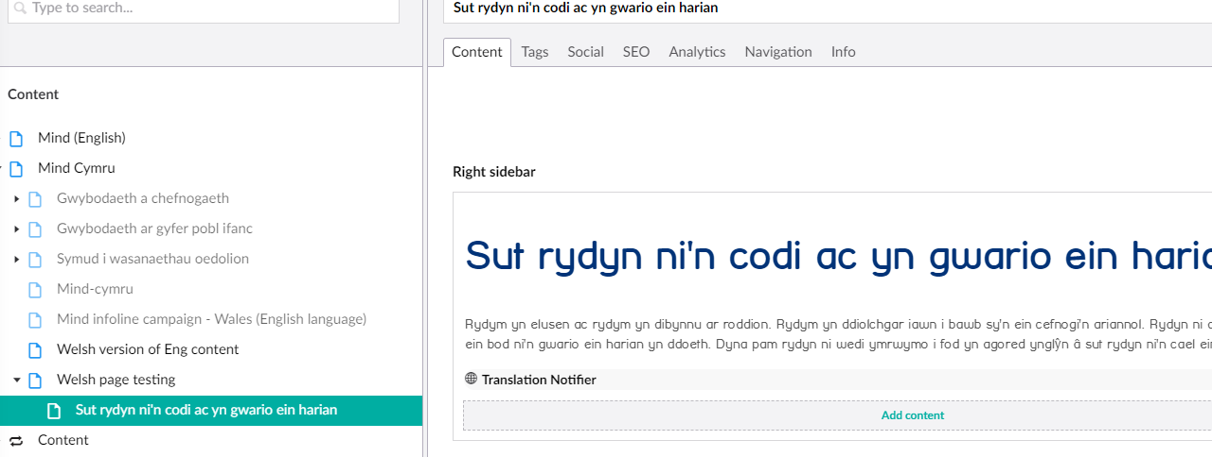

Welsh URL and breadcrumbs
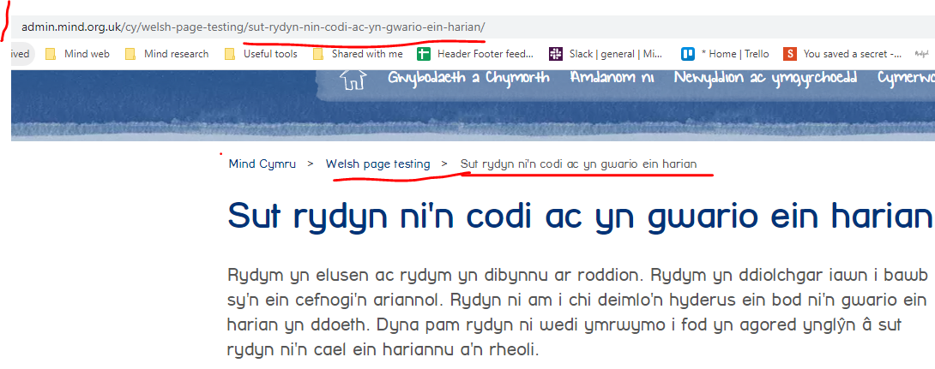

- Update the content to the Welsh version
- Check the tabs:
  - ensure that you SEO tab is completed with Welsh to improve the Welsh SEO of the section of the site
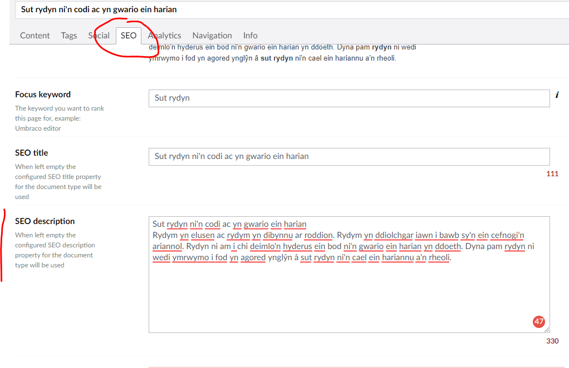
  - Social tab – this will display the Welsh content which has been added to the SEO description tab, you can also customise it in the Social tab
  - Social tab - add a Social image if your page doesn’t have a good image on it in the Brand Logos file we recommend the Blue logo if you don’t have an appropriate image

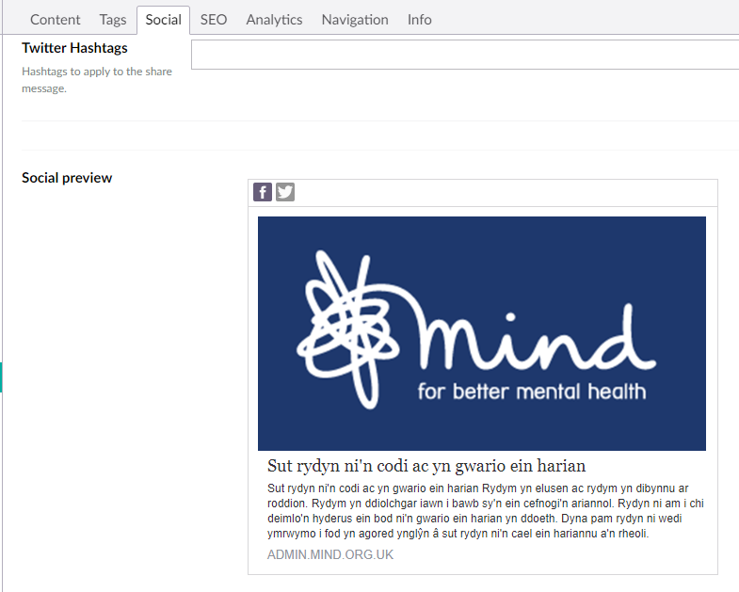
  - For Information product pages in the Navigation add the Welsh Navigation Title

- Links – review the links and update where required particularly the internal links if you want them to be in Welsh.
- Anchor links – update the links so that they link within the page by renaming them, if you don’t do this they will link back to the English version of the page
- Save your content and send to publish both Welsh and English versions

CHECK LIST

- Translation toggle is on Eng and Welsh pages below headline content (Save and publish the Welsh content first and then the English content)
- Page content is in Welsh
- Social tab contains Welsh content
- SEO has Welsh content
- Navigation contains the Welsh language

